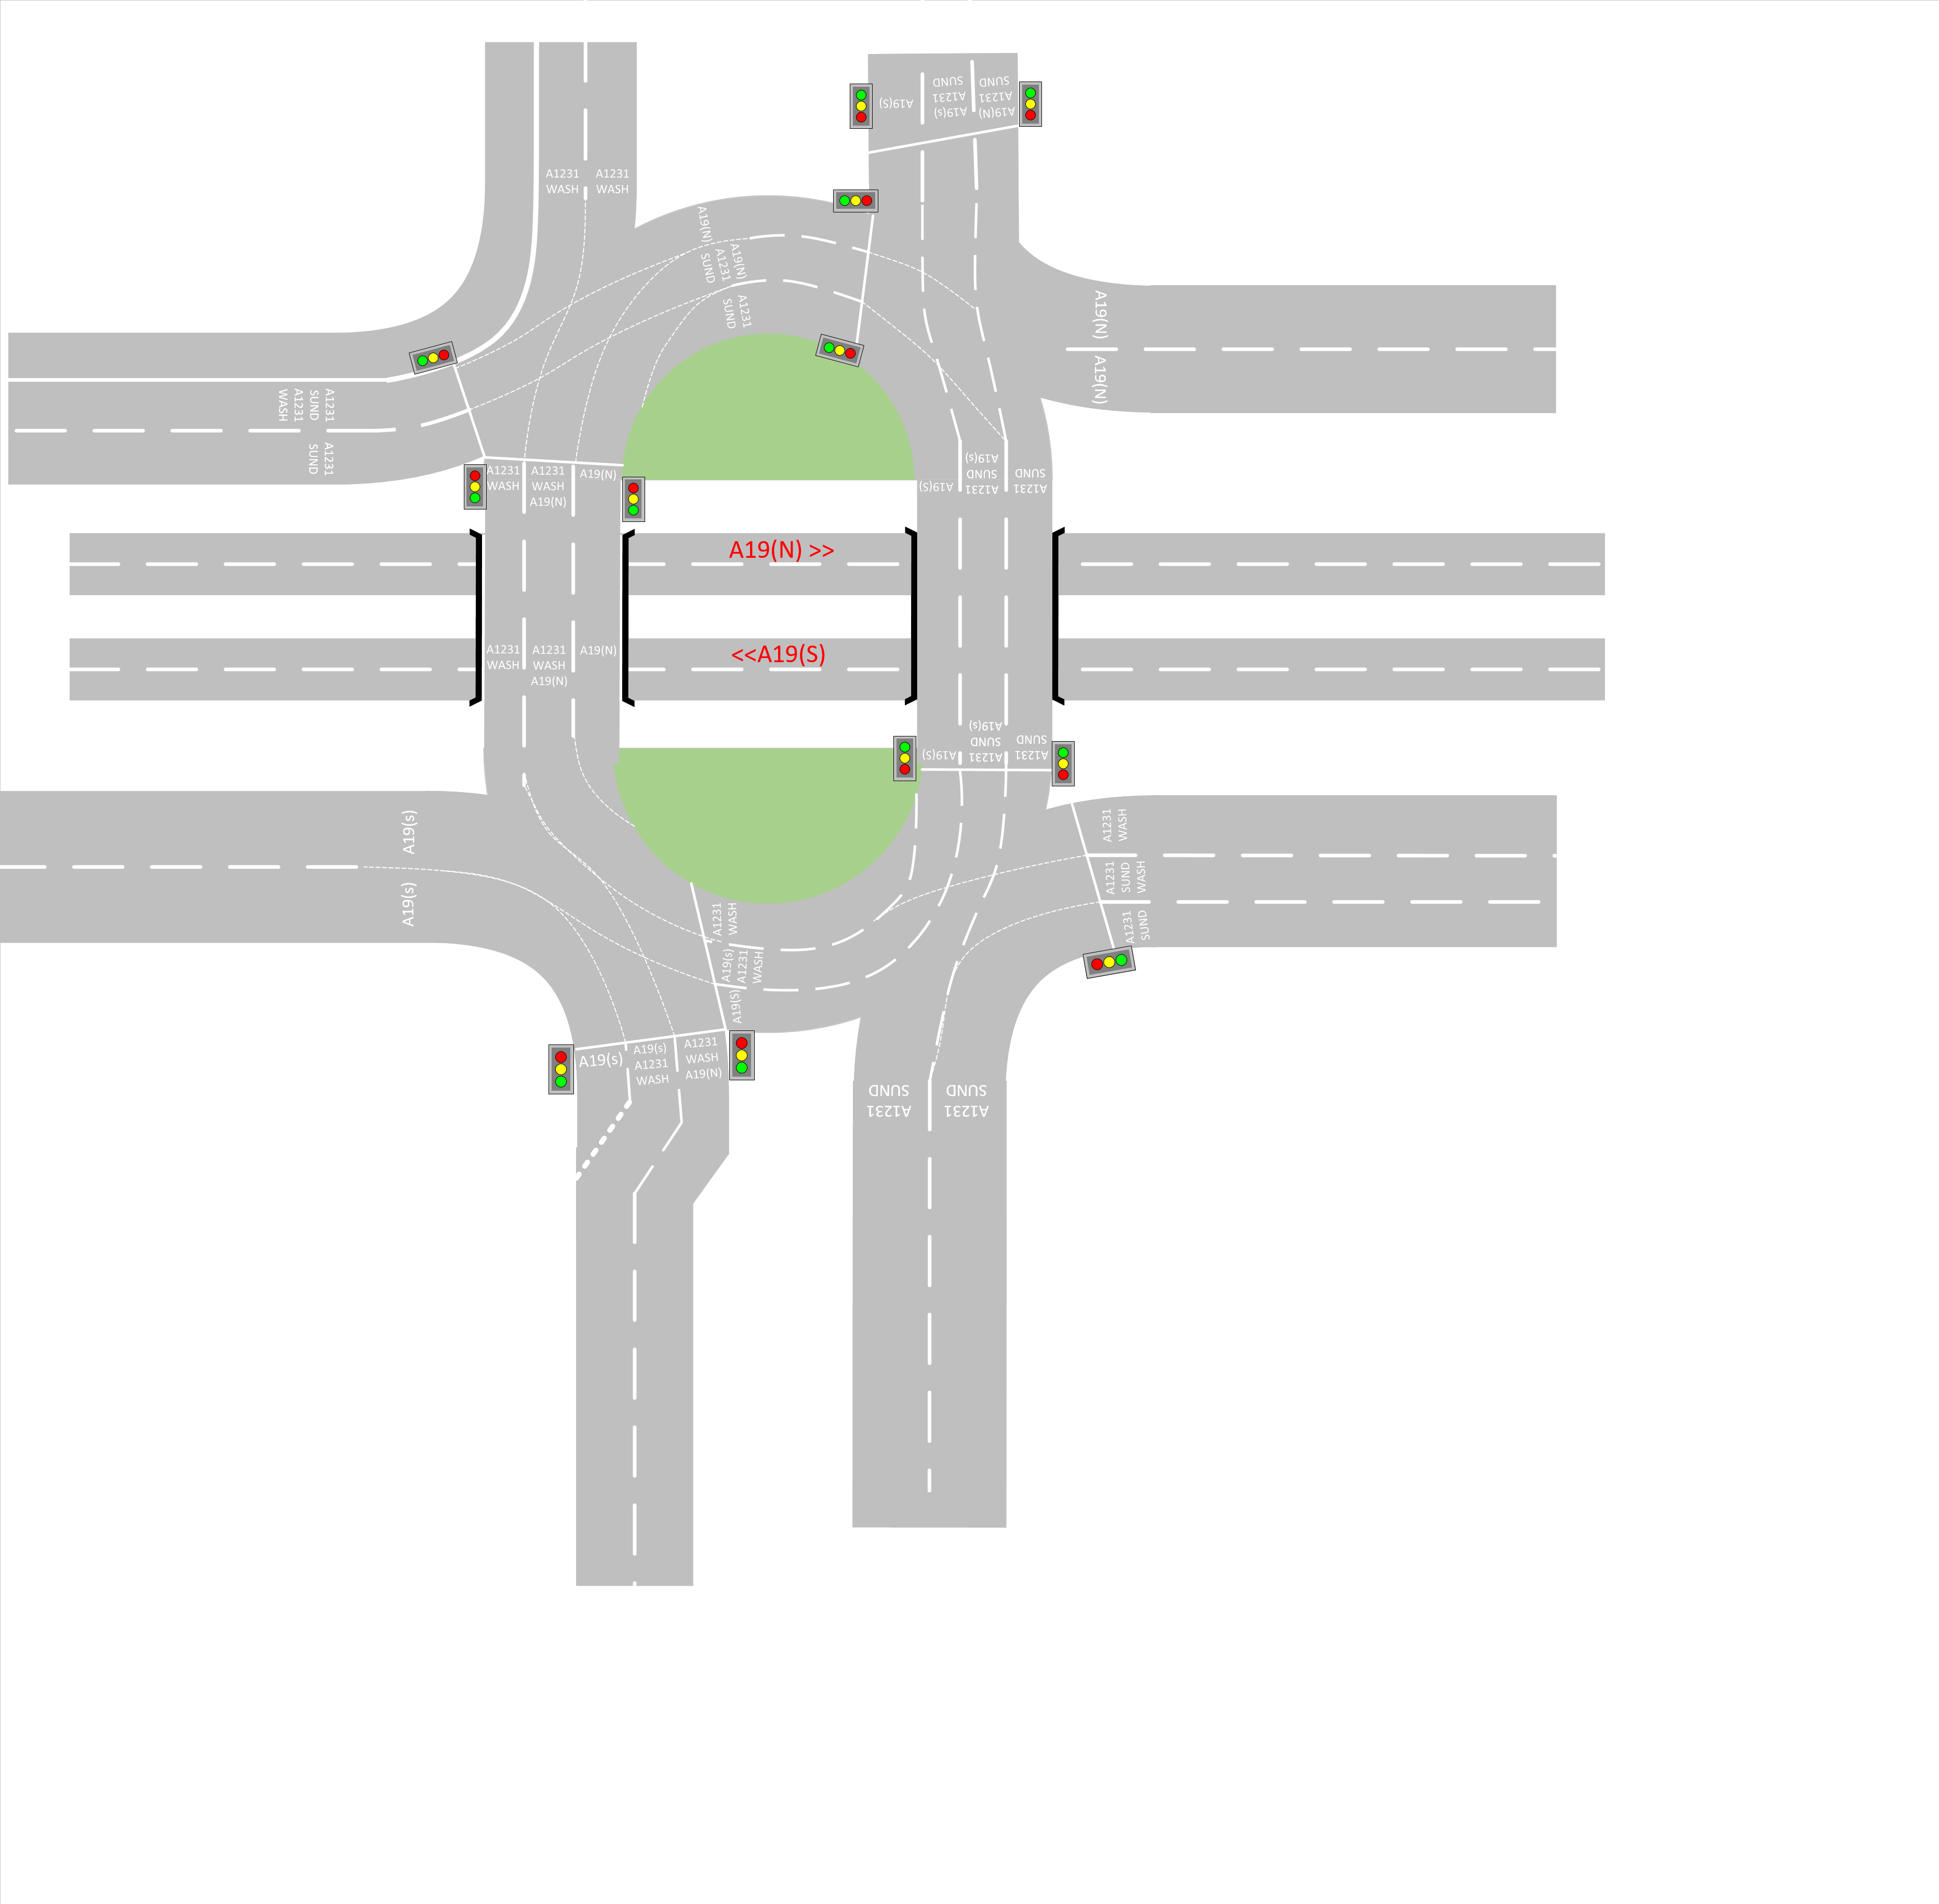

**Wessington Way Spiral Roundabout**